**Connecting the Campus Community in Mental Health Awareness and Support**

Matthew Beaver

Western Carolina University

Introduction to Professional Writing ENG 303

Table of Contents

List of Figures3

Executive Summary4

Introduction5-6

Current Situation 6-11

Problem Statement 11-13

Solutions 14

* Solution #1 Getting the Community involved.14-16
* Solution #2 Digitally Connecting the Community16-20

Recommendation 20

Conclusion 20

Works Cited 20-22

List of Figures

Figure 1: Causes of Stress within a College Student Body8

Figure 2: Belief of Negative Stigmas on Seeking Mental Health Aid10

Figure 3: National College of Health’s 2013 National Assessment of National Student Body’s Mental Health 12

Executive Summary

Within this document I observe current statistics, trends, and consequences of declining mental health within a university setting. When mental health awareness is low within a university student body, it can lead to consequences that negatively impact the campus community. To combat these consequences of declining mental health, I have researched and contemplated numerous solutions. I will then explain how declining mental health can impact a student body when mental health awareness is low, and what solutions I have determined that can be applied within Western Carolina University.

The issue behind a student body’s low mental health awareness and lack of knowledge on current university mental health services lie within the effects of these situations. The effects of being unaware of campus mental health services lower the chances of the student body managing their mental health well. When mental health is neglected within a student body it causes an exponential increase in stress and depression within that student body. This unaddressed increase of stress and depression within a student body can cause a decline in grade point average, increase in student dropouts, and cases of student suicide. However, due to a limited time in the day to accomplish daily tasks other priorities can override managing personal mental health.

The solution I have determined that has the characteristics to contest the specific aspects of the issue for mental health awareness of WCU’s student body is to create an online community. An establishment of an online community will allow for access to mental health support at any location and at any hour of the day. This online community will be a collaborative approach to mental health support which will draw from student interactions with each other and faculty. With the characteristic of being online, numerous avenues for resources will be available to the online community to use in the support of each other’s mental health.

**Introduction**

Awareness of mental health awareness is an essential part of any university’s campus community. Mental health support, awareness, and services to help accomplish mental health awareness should be a part of any higher educational institute. If the mental health of a student is well it will translate to a more motivated and comfortable student on campus. These characteristics of a good state of mental health for a student can lead to an increase in class attendance, a rise in grade point average, the motivation to get more involved in campus events, and more involved in building lasting relationships with other individuals on campus. Western Carolina University recognizes these positive outcomes of a good state of mental health for individual students that make up the entire student body. To support the student body in their mental health, Western Carolina has in place a service for mental health support.

The mental health services on the campus of Western Carolina University take the form of the Counseling and Psychological Services, or as it is commonly abbreviated as CAPS. Even though CAPS are a well-established service on Western Carolina University’s campus, true efficiency of CAPS is limited due to various factors. A main factor that keeps CAPS, or similar campus mental health services, from being truly effective is how unaware the student body is to campus mental health services. A moderate amount of the student body of WCU are unaware of current mental health services on campus like CAPS and thus decrease mental health awareness on campus. This unawareness or neglect of the topic of mental health services within Western Carolina University’s student body can lead to the consequences of declining mental health for the campus community. Therefore, how do we increase mental health awareness and get the student body more involved in the topic of mental health.

**Current Situation**

As it stands, Western Carolina University has established a helpful mental health service that is CAPS. CAPS on Western Carolina University is located within the second floor of the Bird building, and is open to the campus community on Mondays through Fridays from 8 A.M.-5 P.M. To supplement the availability of CAPS, a twenty-four hour, seven days a week emergency hotline for students to reach CAPS has been implemented. CAPS provide the student body with one on one counseling sessions between students and mental health professionals. In addition to in person counseling sessions, the CAPS faculty own a webpage on WCU’s website. The CAPS webpage has essential information on CAPS. The CAPS webpage also allows for easy access to self-help programs or self-assessments on the topic of mental health. However, to get a more introspective look into the overall current state of mental health and mental health awareness, I gratefully interviewed Dr. David Solomon of Western Carolina University. The decision to interview Dr. Solomon was based upon his extensive background in psychology. Dr. Solomon is currently working within his second year as a part of WCU’s faculty, he is the current director of WCU’S Department of Psychology’s M.A. program and works at CAPS on Mondays as a counselor. To add to Dr. Solomon’s credentials of supporting mental health, Dr. Solomon stated he received training upon joining WCU’s faculty to observe signs of declining mental health within individual students. However, upon further inquiry of the mental health observational training Dr. Solomon received, he stated he has not received updates, retraining sessions, or mentions of the training any further from receiving it. Upon inquiring about the current state of CAPS, Dr.

Solomon stated that CAPS is constantly receiving students to come in during the hours of operation. Dr. Solomon emphasizes that the quality of support CAPS provides is very high in providing mental health assistance, and CAPS continues to improve as it receives more resources to support mental health. While working at CAPS on Mondays, Dr. Solomon stated he has personally seen cases where students have emotionally broken down due to stress and depression during counseling sessions. I requested Dr. Solomon’s personal observational opinion on the overall current state of mental health of WCU. At the time of the interview, Dr. Solomon's personal assessment on the mental health of WCU’s student body was that the levels of stress felt were a little above average. To conclude the interview with Dr. Solomon, I asked if there could be any improvements upon the current situation on the handling of the student body’s mental health. What Dr. Solomon expressed towards this question was that when it came to mental health within universities, “improvements can always be made and will always be welcomed.” Despite CAPS doing excellent work as determined from the accounts of Dr. Solomon, a moderate amount of WCU’s student body is unaware of its services and subsequently the student body’s mental health continues to decline. This causes of the WCU student body’s mental health unawareness can stem from WCU student schedules. Within these student schedules, students have limited time within each day to complete a certain number of tasks. This limited time for student tasks each day can lead to prioritizing, assignments, part time jobs and personal errands over managing personal mental health. This same student schedule can lead for WCU’s student body to overlook advertisements for mental health awareness and sevices.

As for the stress WCU’s student body may feel, research done by doctors Saleh, Camart, and Romo (2017) of the Paris Nanterre University, hoped to locate what factors greatly influence

declining mental health within university level students. The factors of declining mental health as researched by Dr. Saleh, Dr. Camart, and Dr. Romo (2017), were: low self-esteem, little optimism, low sense of self-efficacy, and depression. Dr. Saleh, Dr. Camart and Dr. Romo (2017) surveyed a total of 483 French university students within the age range of 18 to 24 for their stress factors survey. Figure 1 shows a visual conclusion, through percentages, on the prominence of factors for stress gathered from the 483-student samples survey, as given by Dr. Saleh, Dr. Camart and Dr. Romo (2017). Figure 1 presents that out of the 483 students within Dr. Saleh, Dr. Camart and Dr. Romo (2007) sample, 56.7% of the sample felt little optimism, 57.6% of the sample felt low self-esteem, 62.7% of the sample felt low sense of self-efficacy, and of the sample 79.3% felt depression. This visual presents an idea of the underlying factors that cause mental health to decline within a university’s student body. These four factors, as determined by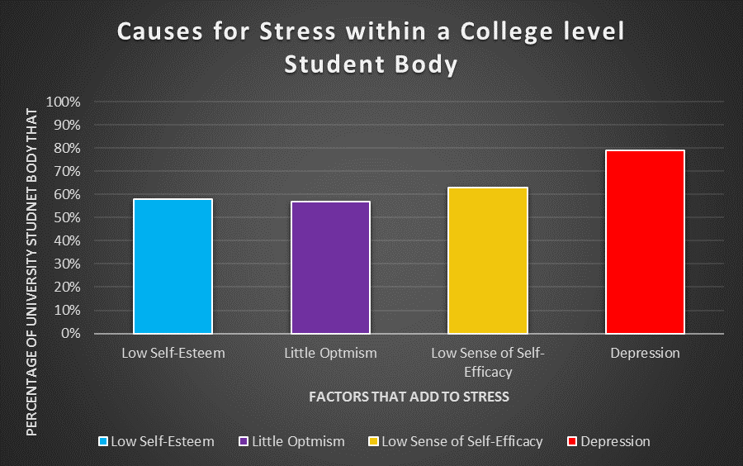

Dr. Saleh, Dr. Camart and Dr. Romo (2007), can be the same four factors that are or can affect the student body of WCU and with the potential of similar percentages in the student body.

To further add to the introspection of what can cause declining mental health within a student body, Steubenville, Ohio’s Franciscan University’s Department of Psychology, Sociology and Social Work (2015) identified personal student characteristics that can potentially cause stress or depression. The Franciscan University Department of Psychology, Sociology and Social Work (2015) was able to determine that students who are: upperclassmen, lived off campus, and were transferring from another higher educational institute felt the most amount of stress. The numbers of university students that may feel the impact of the four factors of declining mental health determined by Dr. Saleh, Dr. Camart and Dr. Romo (2007) and the individual students that fit parts of the criteria of Franciscan University’s Department of Psychology, Sociology and Social Work (2015) can only grow exponentially in number.

To attain a better understanding of the university's student body’s mental health on a national level, Nurse Practitioner Jenna L. Buchanan (2012) noted significant data within a 2009 survey by the National College Health Assessment. The data noted by Nurse Practitioner Buchanan (2012) within the National College of Health Assessment’s survey was out of 80,121-university students 14.9% reported a diagnosis for depression. This 2009 National College of Health Assessment survey of 80,121 does not stop there with significant mental health data noted by NP Buchanan (2012). Further noted by NP Buchanan (2012) with the same survey, reported 32% of the same sample stated they were diagnosed with depression the previous year. According to NP Buchanan (2012), the survey continued to document that 35.6% of the 80,121 students were taking anti-depressant medication, and 24.5% of the same sample were receiving mental health

assistance. As observed by NP Buchanan (2012), the National College of Health Survey showed the rate of depression has only been going up within university students. NP Buchanan (2012) highlighted that in the year 1998, 10.3% were surveyed to have depression. Then Np Buchanan (2012) pointed out a 4.6% growth in the year 2008 which points out an increase to 14.6% of university students that felt depression nationally. Granted these percentages of depression by the National College Health Assessment (2012) are different than those of Dr. Saleh, Dr. Camart and Dr. Romo’s (2007) findings. However, this difference in percentages for the admittance of depression by university students may be due to the negative stigmas of seeking mental health assistance.

During my interview with Dr. Solomon he did confirm that there is a negative stigma of seeking mental health assistance and he personally felt it was due to negative media depictions. Within contemporary media, declining mental health for an individual usually has a dramatic overtone or exaggerated depiction to it. Within these contemporary depictions of an individual with declining mental health, that individual can be perceived as violent, irrational, and mentally insane. This contemporary media factor may be why some university students do not seek out mental health assistance. This is because if a university student were to seek out assistance in mental health, they would be admitting to being similar to the negative depictions of declining mental health. To further look into the current state of negative stigmas behind seeking mental health assistance Professor Karen VanDuesen, Professor Kathryn J. Lewis, and Professor Delores Walcott (2015) reported interesting survey data.

Professor Karen VanDuesen, Professor Kathryn J. Lewis, and Professor Delores Walcott (2015) of Western Michigan University, sought to gather student body perspectives of

knowledge, facts, and stigmas on the topic of suicide prevention and mental health for the usage of suicide prevention programs. Figure 2 showcases some of the resulting data they found within the survey’s they administered to a college level student sample of 819 (Professor VanDuesen, Professor Lewis, & Professor Walcott, 2015). Within the stigma section of the survey, Professor VanDuesen, Professor Lewis, and Professor Walcott (2015) listed the negative stigmas and the percentage of university students who believed those negative stigmas were true. As Figure 2 depicts, 66% of the 819 Western Michigan University students surveyed believed that seeking mental health assistance carried a negative mental health stigma, 12% of Western Michigan University students saw seeking mental health assistance as a sign of weakness, 46% Western Michigan University students believed people would begin to avoid them and 26% believed they would be less likeable for seeking mental health assistance (Professor VanDuesen, Professor Lewis, & Professor Walcott, 2015). My own explanations on the 66% is 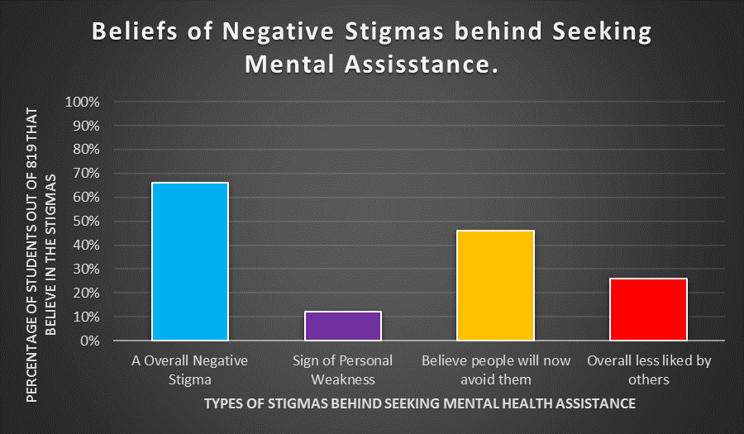

possibly tied to the negative media depiction of declining mental health. Where that 66% of university students believe, they will be perceived like the negative media depictions of declining mental health in various ways. Then for 12% of Western Michigan Universities students, higher educational institutes are seen by their student body as a highly competitive area where only a few can be selected as the best or be adequate to stay enrolled (Professor VanDuesen, Professor Lewis, & Professor Walcott, 2015). Thus, a student seeking mental health is a sign that he or she is not the best or is not adequate enough to stay enrolled. The 46% percent of Western Michigan students believe seeking out mental health assistance will cause their inner circle of people to no longer want to be associated with them. This belief in isolation for seeking mental health assistance may again be due to the perceived negative stigmas, and problems tied to people seeking mental health being too much for those who know them. Finally, the 26% who believe they will be less liked by others might personally feel they will no longer be good enough for anyone they know. This is the collective state of where Western Carolina University may be on the topic of mental health. However, these are just factors that lead into the real problem of what the consequences of decking mental health for everyone individually and collectively can be

**Problem Statement**

A moderate amount of Western Carolina University’s student body is unaware of current mental health services within the campus area. This situation puts WCU’s student body at risk of the consequences of declining mental health. The consequences of declining mental health, when not attended to, are never desirable and never leads a positive impact for anyone. Research found by Dr. VanDuesen, Dr. Ginebaugh, and Dr. Walcott (2015) on the National College of Health’s 2013 Mental Health Assessment of the National Student Body, reveals the percentages of the

current mental health states of university students as of 2013, and is depicted in Figure 3. The National College of Health received their data through a random sample of university students in 2013. As Figure 3 shows from survey results from the National College of Health: 45% of students ``felt things were hopeless”, 31% felt stress to the point they found it difficult to function, 7% had suicidal thoughts, and 17% felt they were overall well in mental health (Professor VanDuesen, Professor Lewis, & Professor Walcott, 2015). Figure 3 easily visualizes the facts that the collective majority percentage of university students were not well within the realm of mental health, and only 17% of the sample could claim they were. Not only does Figure 3 state the feelings caused by declining mental health, but it also implies the impacts it could have on an individual. 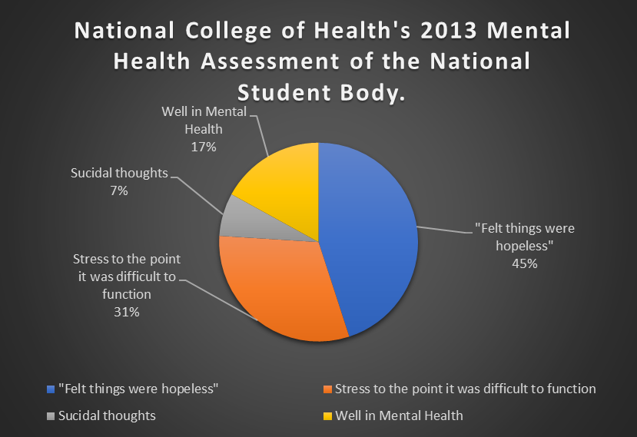

An example of the implicated consequences of declining mental health would be the 31% of university students within the sample that found stress to negatively impact their day-to-day functions. “Stress to the point it was difficult to function” can cause a decline in grade point average for a university student. This is because stress for a university student can keep him or her from focusing or putting enough care into an assignment to attain a passing grade. A decrease in grade point average may not be the only impact of being stressed to the point it becomes a hindrance in work for a student. To alleviate this feeling a student may decide to miss assignments, tests, class, and may lead to the regretful decision of dropping out of his or her higher educational institute. Another part of Figure 3’s pie chart implies a worse consequence, and that is the 7% of university students with suicidal thoughts. Despite it being only 7%, the lowest percentage of Figure 3, there are university students that act upon those thoughts.

As recorded by Dr. Keye Lees (2014) of the University of Alabama, The Centers for Disease Control and Prevention estimate that out of every 100,000 students, 6.5 to 7.5 commit suicide with a yearly suicide rate totaling 1,100 of university students (Dr. Lees p.3). Dr. Lees (2014) also applied a 1999 statistic that stated an estimated 10% of college students had suicidal thoughts. With this estimate, Dr. Lees (2014) believed that approximately 3,000 out of the 14,000-student body of the University of Alabama had suicidal thoughts. Applying this own approximation to Western Carolina University’s student body of 11,639, WCU there would be an approximate total of 1,163 students with suicidal thoughts. However, as previously stated within the Current Situation section, that percentage of approximately 10% has increased by 4.6%. This percentage increase of university students with suicidal thoughts would place the approximate WCU students with suicidal thoughts at 1,629 as of 2009. This number can only increase as the student body goes unaware of mental health topics and services. However, student schedules

alongside perceived priorities such as finances and grade point averages may cause the student body to overlook advertised mental health assistance.

**Solutions**

Western Carolina University’s student body needs an increased number of open discussions, interactions and acknowledgements of mental health awareness on campus to oppose the rise of mental health difficulties. There are multiple solutions for Western Carolina University’s student body to get the campus community as a whole more involved with the current state of mental health awareness.

**Solution # 1: Increasing Community Involvement**

The main constant support system for mental health on the campus of Western Carolina University’s campus is the community. WCU’s campus community includes the student body, the faculty, club presidents, employees such as cafeteria staff and the employees of CAPS. Every part of the campus community needs to get involved and a way to begin this campus community collaboration is to gain mental health information. This mass of knowledge about mental health can come in the form of a mental health workshop accessible to both students and faculty. Maria del C. Fernandez Rodriguez (2013) a clinical psychologist Professor of the University of Puerto Rico, and Professor Ivonne Bayron Huertas (2013) discussed the creation of the Suicide Prevention Program for university students. Professor Rodriguez and Professor Heurtas (2013), during the creation of Suicide Prevention Program, wanted to bring every sector of a college campus to meetings to implement suicide prevention programs within the University of Puerto Rico’s campus. This meeting concept is something that Western Carolina University can use

itself in a way of improving mental health awareness. The faculty, student body, or both can attend a meeting where ideas can be presented and improvements on mental health awareness can be shared. The student body in this meeting, can implement and point out mental health awareness areas that need the most improvement. The faculty’s role within these meetings can be a determiner on whether ideas or suggestions can be implemented and be a voice to begin the action of putting them in place. Meetings are not the only way determined to connect the campus community against declining mental health.

Again, I would like to mention my interview with Dr. Solomon and point out the mention of training with the purpose to identify declining mental health. Dr. Solomon’s mention of mental health training aligns with the idea of Professor Rodriguez’s Suicide Prevention Programs mental health training workshops. If the workshops take place on WCU’s campus, it will allow for the determination of content found within by WCU’s faculty and students. The content the faculty of WCU can consider including in these workshops for mental health awareness can be statistics on declining mental health, information on CAPS, the consequences of declining mental health, combating the negative stigmas, and where students can begin gatekeeper programs.

The gatekeeper aspect is very important in learning the signs of declining mental health, and how to carefully handle a situation that includes a person with declining mental health. As noted by Professor Rodriguez and Professor Huertas (2013), gatekeeper programs recognize the QPR method which stands for: question, persuade, and referral. The QPR model is made to train individual’s on how to carefully question others with declining mental health, how to persuade them to seek help, and to finally refer them to the mental health professionals they need to meet with. However, these mental health workshops will be extended to students as well as faculty.

This extension to students for being able to enter workshops is best explained by Professor Rodriguez and Professor Heurtas (2013). Both Professor Rodriguez and Professor Huertas (2013) assessed that having multiple people who took part in the workshops the more spread out mental health awareness will be on campus. Professor Rodriguez and Professor Huertas (2013) also explain that students are more comfortable sharing personal reasons for declining mental health with individuals of a similar age. Thus, including students in these workshops will create a father reaching sub-community of mental health specialists that can provide a more comfortable atmosphere for engaging students with declining mental health. This student to student discussion can lead to proper implementation of the learned QPR method and possibly promote involvement for future mental health workshops.

Where these mental health workshops and sub communities can proceed to take action towards is to become fully connected in a club like setting. As mentioned by Dr. Lees (2014), the University of Alabama has a specialized team specializing in critical incident responses within the realm of declining mental health. WCU establishing a team of individuals composing of both faculty and students using the QPR method when needed will help increase mental health awareness within the campus community. This team would work alongside Western Carolina University’s CAPS where this specialized team can help establish events, and begin posting mental health service advertisements. The specialized WCU mental health team can hold weekly meetings to gain updates on planned mental health events, where they need to advertise more, and keep in touch with each other. An example of an event this mental health team can establish by Dr. Lees (2014) mentioned a mental health awareness or suicide prevention community walk for the University of Alabama. Western Carolina University can hold a similar mental health

awareness event established by this mental health team, placed within the nearby mountains or the more populated Asheville.

**Solution 2: Connecting the College Campus Community Digitally**

With today’s technology, doors have been opened for new and innovative ways of approaching mental health. Today’s technology allows for easy efficient ways of communicating and connecting numerous people in almost any location at any time. With the abilities that today’s technology allows, WCU can create a collaborative online community that can be tied to the CAPS website, can be a lone website on the topic of mental health awareness, or a simple Facebook group. To promote WCU’s mental health online community, advertisements on the WCU’s bulletin boards can be posted, student orientations can give brief statements, and WCU’s faculty can mention the online community during class. Research by Dr. David Luxton, Bachelor of Arts graduate Jennifer D. June and Dr. Julie T. Kinn (2011) of The National Center for Telehealth and Technology showed that an average of 90% of university students go online daily. To correlate with Dr. David Luxton’s B.A. Graduate June, and Dr. Kinn’s (2011) percentage of university student that go online, Dr. Yael Perry, Dr. Aliza Werner-Seidler, Dr. Alison L. Calear, and Dr. Helen Christensen (2016) of the Canadian Academy of Child and Adolescent Psychiatry stated that teenager groups are 92% likely to go online at some point in the day. These percentages of a daily online presence, presented by mental health professionals, show that the online landscape is a good place for providing mental health awareness programs. The mental health landscape that WCU can construct can be a provider for information on many topics of mental health awareness and connect the campus community for mental health support.

Dr. Luxton, B.A. graduate June and Dr. Kinn (2011) mention the establishment of discussion boards or forums to create the groundwork for mental health support online. However, the first step would be the establishment of online rules where possible user agreements must be read and agreed upon before contributing to the online discussions. The rules for these mental health discussion boards or forums will be based upon levels bullying, breaches of privacy, and levels of appropriateness. With the breaking of any of these rules, a student or faculty moderator of the site or discussion board will implement a permanent ban upon the offender. Each forum or discussion board can have different topics all based upon the core topic of mental health. These topics for discussion for mental health can include the statistics behind declining mental health, and information on Western Carolina University’s CAPS. Dr. Perry, Dr. Werner-Seidler, Dr. Calear, and Dr. Christensen (2016) noted an interesting application for an online mental health community that can also be included. Dr. Perry, Dr. Werner-Seidler, Dr. Calear, and Dr. Christensen (2016) thought of the idea that an individual student can seek out online gatekeeper programs or find locations for gatekeeper programs nearby. Student involvement in the form of conversations, within this online mental health community, between each other will be an essential part of digitally connecting the community for mental health support. These discussion boards or forums will allow students to share personal reasons for stress or depression with each other to let all of those negative emotions out. By sharing these stressors words of encouragement may arise in the form of personal stories of successfully handling declining mental health or in the form of tips on how the student does it. To further support a brighter community a discussion topic of videos, pictures or stories that helped an individual go through declining mental health or get through a tough day. With strong, efficient, accessible, student interactional mental health support it can lead to students taking the initiative in mental health awareness by organizing group therapy sessions or events. Overall, conversations within the student body within online mental health

discussion boards or forums can create more open discussions on mental health and create a sense that no student is alone. These mental health forums or discussion boards will not be student body exclusive. Faculty of Western Carolina University and mental health professionals will be encouraged, asked or willingly contribute to the online mental health community.

**Recommendation**

My recommendation for bringing more mental health to WCU’s student body and do it in an easily accessible collaborative way would be solution 2. Solution 2 is to introduce a mental health online community to WCU’s campus community. I recommend Solution 2 for the reasons that it opens up many topics of discussion and action online in a variety of ways from just discussing stress, to student planned group therapy sessions. The accessibility of an online mental health community allows for an individual WCU the ease of being able to partake with the online community anytime, anywhere and with any schedule.

**Conclusion**

Western Carolina University has many mental health services that are well established with professional individuals likened with proper training to provide student counseling. The objective of this paper is to bring up the issue of these mental health services going unaware by the WCU student body, the consequences of declining mental health and the discussion of the implementation of methods that can combat declining mental health. This document was made with the intentions that mental health awareness is more prominent within WCU’s student body and on campus. Dr. Solomon as stated within the interview had with him a higher educational institute can always welcome and improve in mental health. By improving upon mental health awareness and creating new services for WCU’s student body it will create a better community experience, make campus life more comfortable and increase the number of students making it to graduation day.

Works Cited:

Buchanan, J. L., PhD. (2012). Prevention of Depression in the College Student Population: A Review of the Literature. *Archives of Psychiatric Nursing,26*(1), 21-42. doi:https://doi.org/10.1016/j.apnu.2011.03.003’

Fernandez Rodriguez, M. C., & Huertas, I. B. (2013). Suicide Prevention in College Students: A Collaborative Approach. *Interamerican Journal of Psychology,47*(1), 53-60. Retrieved October 26, 2018, from <https://www.ncbi.nlm.nih.gov/pmc/articles/PMC3809451/>.

Keyes, Lee, PhD. (2014). Alabama Counseling Association Journal. *Suicide and Its Prevention on College Campuses,38*(2), 11-15. Retrieved October 26, 2018, from <http://www.alabamacounseling.org/pdf/journal/specialedition/special.pdf>

Luxton, D. D., Ph.D., June, J. D., B.A., & Kinn, J. T., Ph.D. (2011). Technology-Based Suicide Prevention: Current Applications and Future Directions. *Telemedicine and E-Health,17*(1), 50-54. doi:https://doi.org/10.1089/tmj.2010.0091

Perry, Y., PhD, Werner-Seidler, A., PhD, Calenar, A. L., PhD, & Christensen, H., PhD. (2016). Web-Based and Mobile Suicide Prevention Interventions for Young People: A Systematic Review. *Journal of the Canadian Academy of Child and Adolescent Psychiatry,25*(2), 73-79. Retrieved October 26, 2018, from <https://www.ncbi.nlm.nih.gov/pmc/articles/PMC4879946/>

Saleh, D., Camart, N., & Romo, L. (2017). Predictors of Stress in College Students. *Front Psychol,8*(19). doi:https://dx.doi.org/10.3389/fpsyg.2017.00019

VanDeusen, K. M., Lewis Ginedaugh, K. J., & Walcott, D. D. (2015). Campus Suicide Prevention: Knowledge, Facts, and Stigma in a College Student Sample. *5*(2), 1-9. doi: [https://doi.org/10.1177/2158244015580851](https://doi.org/10.1177%2F2158244015580851)